Patterns:
For the sake of transparency, I will be judging based on Rainstorm (Normal) mode. I wanted to judge on Monsoon (Hard) mode but I had the bright idea to insist on playing as Solaris.

Tip: don’t do that

“MAGICAL CUTE FOUNTAIN” - 35

I swear I’ve seen a pattern like this in one of your other games, but I digress…

Anyways, this is simple, but it gets the job done. I think the bullet fountain type of pattern is really pretty, and its handled in a way here that doesn’t make it feel like an RNG fest. Largely because the density is traded out in favor of lasers. It’s nice.

“ADORABLE MAGICAL SPIRAL” - 30
This one kinda loses the plot a little. It’s not a bad pattern, but I find the large bullet walls feel a bit too oppressive, and the big player sprites and relatively fast movement speed makes it kinda uncomfy to dodge. I think the aimed bullets are nice, at least, I just wish the secondary component was a lot nicer-looking.

“DREAMY EVACCANEER” - 40
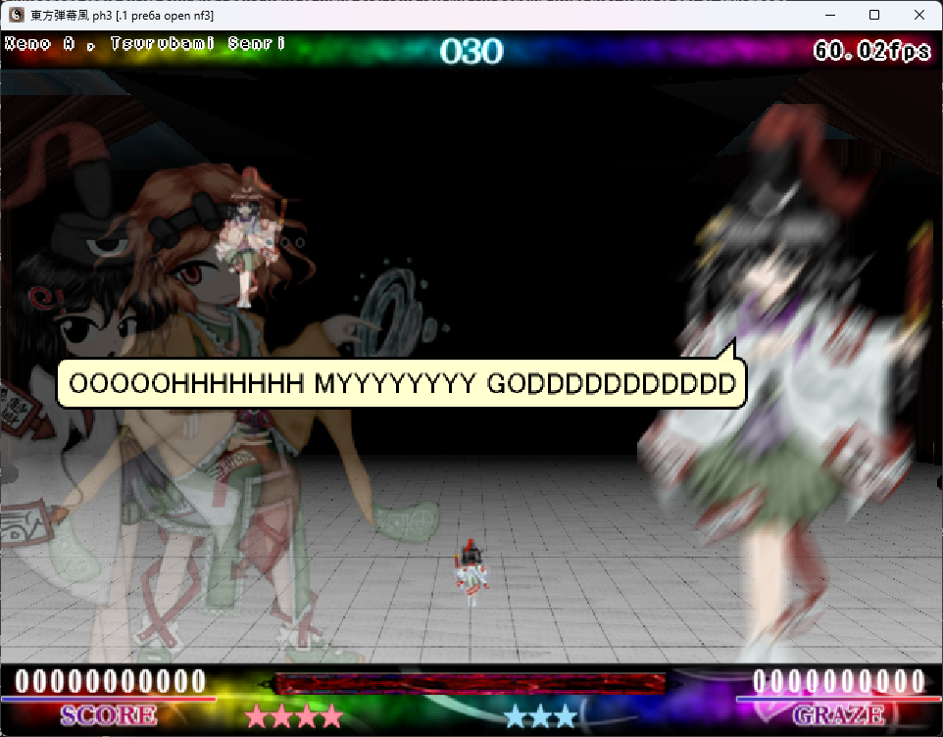

“BULWARK OF THE TALENTED” - 50

This pattern constitutes the entire second half of the boss, but while it’s split up into phases, the bullet patterns don’t feel distinct enough to treat it as 4 separate spells, so I’ll be treating it as one pattern.

This is the absolute best set piece in the script. It’s an adaptation of the chart for “King of Lions” from Noisz Starlivht, but even knowing that, it’s still really well-done. I know it's taken straight from Noisz, but the use of the overkill mechanic to still incentivize offensive play even throughout what’s basically one long survival. Patterns are well telegraphed and have you zipping around all over the place, the use of familiars make the good visual feedback from the stage remain present here. It’s so long and elaborate and it’s hard to really pinpoint the specifics, but I do like how, despite being a big Noisz reference, it’s still very distinct due to the new sections added to replace what the original chart had note charting for.
It’s a good pattern, I love it.

Total Score: 38.75 Points

Design: 25 Points
Honestly, probably one of the more creative uses of the theme here. Like, the game is haunted. There is something haunting this game and it follows the tropes of haunted games. It’s just that, rather than being haunted by some demonic entity, it’s haunted by a cat who goes :3 and earnestly doesn’t have anything sinister behind that. I like how the menu design makes you think there’s something sinister going on, but then oops, it’s just a cat. The game is also just plain fun. Like with most of your games, there’s an in-depth scoring system here which is always appreciated. I like how quickly you gain extends too if you use the mechanics, it feels very rewarding and makes these sort of short arcade-style scripts a lot more accessible. If there is anything holding me back from giving this a solid 30, it’s that I feel like the “Bulwark of the Talented” part loses the plot a little. Feels more focused on the cool factor than on continuing the “cute kitty haunts a gritty stg” idea. It’s not a big deal though, and I still absolutely adore that part of the script. Plus the aesthetics of the creature haunting the game do properly lead into the big extended King of Lions reference, so it’s all good.
Also the stage design is fun and engaging, and is especially satisfying when working in tandem with the mechanics. I find it hard to describe what makes stage design “good” (if anything I’m better at pointing out what not to do for stages), but this is good stage design and it’s worth highlighting.

Presentation: 19 Points
I don’t like the graze sound effect that was used. That’s it. Everything else looks pretty good. Anything that feels unpolished moreso compliments the whole “haunted unnamed prototype” vibe, and I find the cats cute.

Total: 82.75 Points
This script singlehandedly got me to get off my ass and play Noisz Starlivht. I feel like “Bulwark of the Talented” really is the standout part of the script. I find the stage engaging too, but I can’t help but feel like the boss patterns before Bulwark kinda forgettable? Not bad, just nothing special. Jesus, I can’t emphasize enough how good Bulwark was though, it’s so fucking hype. Also genuinely amazing you got Camilla’s permission to use King of Lions.

